Reveiling Volunteer Platform Heterogeneities – Focus Interactive Diagrams

Project Aim
This project aims to analyze and visualize the heterogeneities of digital volunteer platforms by building a structured catalogue of features (e.g., volunteer profiles, task types, gamification elements, community support, etc.) and representing them interactively.
The main goal is to make the differences between platforms easily explorable through a diagram-based web tool that supports filters (e.g., platforms supporting “interest”-based matching or gamification).
The platform selection covers both international and Austrian systems. It also allows for future extension via data crawling, probably with XML-based input/output.

Planned Schedule – Roadmap
- Platform selection and Excel database preparation
  - Kinda done, Some of the key features should be rephrased and grouped under more general categories to allow for proper comparison across platforms.
  - For example:
The following terms – "E-Learning course", "course", "online course", and "E-Learning" etc.– could all be grouped under a broader category such as "Learning/Training Modules".
- Catalogue of heterogeneities finalized as mindmap <- We are somewhere here
  - I have a mindmap, but it’s a bit basic
- Selecting Environment, Prototyping of diagram structure and interactivity requirements
- First implementation of visualization (static + filtering logic)
- Platform entries expanded and adjusted for diagram input
- Feedback and refinement phase
- Finalization of prototype and preparation of documentation
The first three steps can be completed with minimal time investment. After our meeting, it will be possible to make a more precise time estimation for the remaining phases, as we will clarify the specific expectations and goals of the project during that discussion.
Also, I have created a visualization (about how I imagined this project). I imagined a card view with a feature matrix + a filtering panel. To visualize this, I used a generative tool, nothing is set in stone yet. I just wanted to show how I imagine this problem.
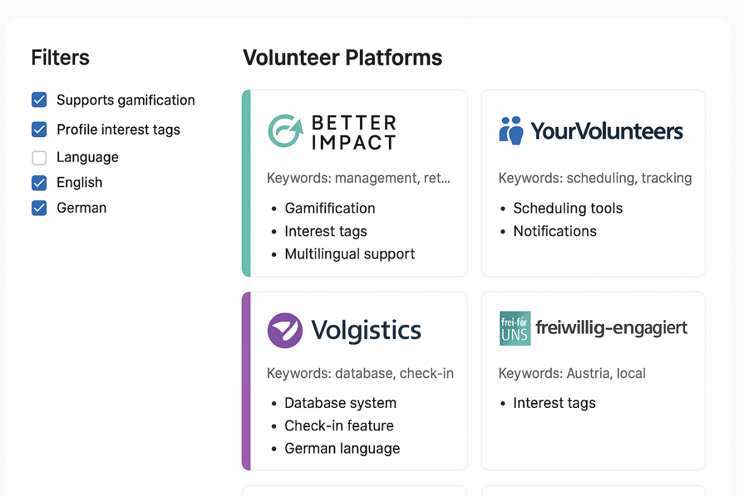
-Grouping of features by mean
-One lvl deeper in features like interest (own columb) filter
-how the attributes deal with the issues
-reminder about master thesis work github

22.07
-reminder about master thesis work github
-check it again
-python is okay
-make it interactive, click on it and get more information
-navigation about the filtered feature (click ont he venn)
- PPT evaulation, translation from german
- Build in the registration forms/ other forms (maybe screenshots)
- Build some POC (requirement engineering)
-library diagram search what is the best that I can use
-sunburst diagram
-Mockups
26.08.- 3PM for next meeting

